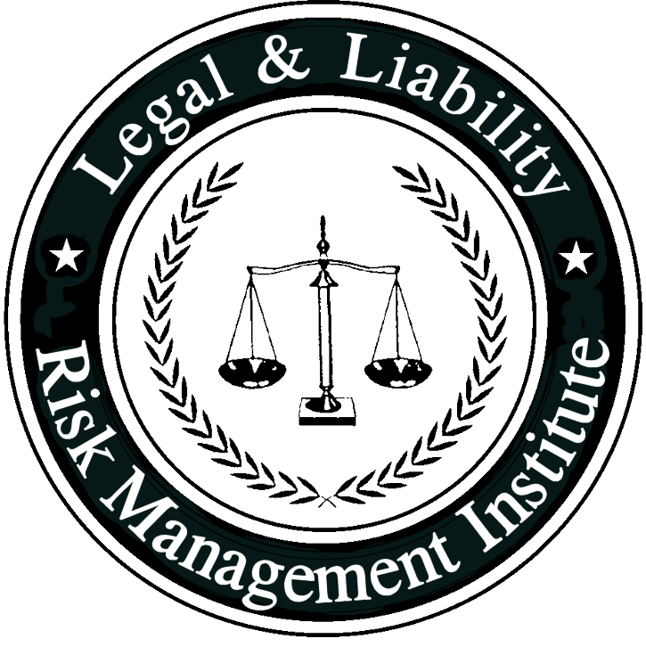

Alcohol Policy | Related Policies:  Random Drug/Alcohol Testing, Reasonable Cause Drug/Alcohol Testing, Random Drug/Alcohol Testing
This policy is for internal use only and does not enlarge an employee’s civil liability in any way. The policy should not be construed as creating a higher duty of care, in an evidentiary sense, with respect to third party civil claims against employees. A violation of this policy, if proven, can only form the basis of a complaint by this department for non-judicial administrative action in accordance with the laws governing employee discipline.
Applicable KY Statutes:
OSHA:
NFPA Standard: NFPA 1500 Ch. 10.1.5
Date Implemented: |  | Review Date:

- Purpose: The purpose of this policy is to set forth the department’s mandates with respect to alcohol use prior to and while engaged in fire department activities.
- Policy: It is the policy of this Fire Department to adopt a “zero-tolerance” standard regarding the use of alcohol by members of the department at any time when they may be called upon to act or respond as a member of the department.
- Definitions

Alcohol: For purposes of this policy only, the term alcohol shall include any intoxicating liquor, alcoholic beverage, beverage to which alcohol has been added, and any so-called non-alcoholic malt, harps or similar near beer or low-alcohol beer-like beverage.

Under the influence: Any member who has consumed alcohol within the previous eight (8) hours, is still noticeably impaired by alcohol consumed prior to eight (8) hours, or any member having a blood alcohol level of .02% or higher irrespective of when the alcohol was consumed.

Uniform: For purposes of this policy only, the term uniform refers to station uniform consisting of station uniform pants and station uniform shirt; dress uniform consisting of dress uniform pants, shirt, and jacket; or personal protective equipment consisting of turnout coat, turnout/bunker pants, boots and helmet.

In Uniform: For purposes of this policy only, being in uniform shall include wearing any one part of the uniform in conjunction with some other piece of clothing which together identifies an employee as a member of this department. For example, wearing dress uniform pants along with a non-uniform fire department oriented t-shirt naming this department constitutes being in uniform for purposes of this policy. Wearing a station uniform shirt with civilian shorts constitutes being in uniform for purposes of this policy. However, a member who wears civilian attire that merely names this department shall not be considered to be in uniform.

Editor’s Note: Fire departments should edit these definitions as required for their specific needs. Some departments may choose to define “In Uniform” for the alcohol policy as including the wearing of any clothing that names the department; some may choose to include the wearing of any item of clothing that is “department issued”. Volunteer departments may choose to omit language relative to station uniforms, or define it as applying solely to the wearing of turnout gear as applicable. It is important to limit the applicability of this policy to this policy so as not to conflict with normal uniform requirements.

- Procedure

- No employee shall consume alcohol while on duty or while in uniform.

- No employee shall report for duty under the influence of alcohol.

- No employee shall participate in any fire department activity under the influence of alcohol, including but not limited to training, meetings, events, parades, assignments, details, duty shifts, work shifts, substitutions, emergency response, or emergency scene activity.

- No alcohol shall be brought onto, stored upon, or possessed by any employee on the premises of any operational portion of a fire station, including but not limited to the apparatus floor, the station living areas, lockers, equipment rooms, storage areas, bathroom and shower facilities, sitting rooms, etc.

- No alcohol shall be permitted to be carried on, transported by, or stored upon any fire department vehicle.

- Blood alcohol testing shall be conducted in accordance with department drug and alcohol testing policies and procedures.

Editor’s Note: Fire and emergency service agencies/organizations that raise funds by operating and/or renting social halls that serve or allow alcohol must provide a clear and distinct separation of facilities to help insure the zero-tolerance standard of alcohol consumption by their members who may be called upon to perform official duties.

